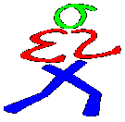
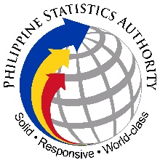
26th NATIONAL STATISTICS MONTH AWARDS
Nomination Form for Best Youth Advocate for Statistics

Nominated Organization: _________________________________________

Nominating Official’s Name: ______________________________________

_____________________________ _________________ _________________
Signature Designation Date

Organization: _______________________________________________

Address: ___________________________________________________

Contact Person: _____________________________________________

Contact Numbers:
Telephone No._____________________________________
Cellphone No._____________________________________
Fax No. __________________________________________
Email address: _____________________________________

Information on the Statistical Advocacy Activities of the Organization

List, description and objectives of various statistical advocacy activities conducted by the organization in 2015

Description of the impact or image projected by the activities conducted

Extent of participation of other organizations, LGUs and sectors of the society (e.g. number of participants)

Description of materials/resources used, sponsorships/partner organizations and expenses incurred

Other relevant information for the evaluation

(Additional information may be provided in separate sheets, if necessary.)

CHECKLIST

Accomplished Nomination Form

Photographs (printed or e-copy format) and/or video of the activities

List of outputs and outcomes of the activities conducted

Information on the coverage and beneficiaries of the activities

Total expenses incurred and list of resources used for the conduct of the activities

Weblinks on the activities (YouTube, social media, websites, online news articles, etc.), if any

_________________________________________________________

DEADLINE OF SUBMISSION: 7 July 2016

26th National Statistics Month Secretariat
c/o Ms. Lotis I. Ira
Officer-in-Charge
Statistical Policies and Programs Division
Philippine Statistics Authority
17th Floor Eton Centris Cyberpod Three, EDSA Corner Quezon Avenue,
Diliman, Quezon City
Telephone No.: (632) 376-1928, (632) 376-1879;
E-mail Addresses: l.ira@psa.gov.ph , nationalstatmonth@gmail.com

