**Approved Foreign Investments in the Philippines**

# Second Quarter 2016

### Summary

**Total approved foreign investments (FI)**[1]**, Q2 and first semester 2016**

Total foreign investments (FI) approved in the second quarter of 2016 by the seven investment promotion agencies (IPAs), namely the Board of Investments (BOI), Clark Development Corporation (CDC), Philippine Economic Zone Authority (PEZA), and Subic Bay Metropolitan Authority (SBMA) as well as the Authority of the Freeport Area of Bataan (AFAB), BOI-Autonomous Region of Muslim Mindanao (BOI-ARMM), and Cagayan Economic Zone Authority (CEZA), amounted to PhP 40.4 billion, higher by 11.5 percent from PhP 36.2 billion recorded in the same period last year. Meanwhile, total approved FI for the first six months of the year reached PhP 66.6 billion, an increase of 14.8 percent from PhP 58.0 billion in the previous year.

The top three prospective investing countries for the second quarter of 2016 include Singapore, Japan and South Korea. Pledges from Singapore amounted to PhP 10.2 billion or 25.1 percent share during the quarter while Japan and South Korea committed PhP 7.1 billion and   
PhP 5.1 billion, or 17.5 percent and 12.7 percent of the total approved FI, respectively.

For the first semester of 2016, Singapore led the list, with commitments amounting to   
PhP 12.6 billion or 18.9 percent. The Netherlands and Japan followed with pledges amounting to PhP 11.8 billion or 17.7 percent and PhP 11.4 billion or 17.2 percent, respectively.

Manufacturing continued to be the industry that would receive the largest amount of committed foreign investments in the second quarter of 2016. Investments for Manufacturing stood at   
PhP 14.2 billion or 35.3 percent share. Construction came in second with investment pledges valued at PhP 8.2 billion or 20.4 percent, followed by Administrative and Support Service Activities at PhP 6.2 billion or 15.4 percent share.

During the first half of 2016, Manufacturing maintained the top post, with commitments of   
PhP 24.1 billion, accounting for 36.1 percent. This is followed by Administrative and Support Service Activities at PhP 11.6 billion or 17.4 percent and Electricity, Gas, Steam and Air Conditioning Supply at PhP 10.5 billion or 15.7 percent.

About this report

# Inside

# Part I - Analysis

A. Approved foreign investments…………………….... 4 to 14

B. Approved investments of foreign and Filipino nationals……………….. 14 to 21

C. Approved investments in the

Information and Communications Technology (ICT) Industry………………..…….….. 22 to 24

D. Actual foreign direct investments

in the Balance of Payments…… 24 to 25

###### Part II – Statistical Tables

###### Annexes

This report is the 76th of a series on quarterly statistics on foreign investments (FI) in the Philippines, integrating the quarterly statistical reports on FI submitted by the government’s investments promotion, administration and regulation agencies. It provides an analysis of the:

1. *Foreign investments* (FI)and *investments by Filipinos approved* by the Board of Investments (BOI), Clark Development Corporation (CDC), Philippine Economic Zone Authority (PEZA), Subic Bay Metropolitan Authority (SBMA), Authority of the Freeport Area of Bataan (AFAB), BOI-Autonomous Region of Muslim Mindanao (BOI-ARMM), and Cagayan Economic Zone Authority (CEZA);
2. *Foreign direct investments* (FDI) in the Balance of Payments (BOP) as compiled by the Bangko Sentral ng Pilipinas (BSP).

Approved foreign investments represent investment commitments and pledges by foreigners regardless of the percentage of ownership of the ordinary shares, which may be realized in the near future while FDI refers to actual foreign investments generated, with the foreign investors owning 10 percent or more of the ordinary shares.

Annex A presents the technical notes on the data and compilation methodology while Annex B gives a brief background on the Foreign Investment Information System (FIIS) that generates the FI statistics presented in this report.

In terms of location, bulk of the approved foreign investments in the second quarter of 2016 would be intended to finance projects in Region IVA – CALABARZON, amounting to   
PhP 15.9 billion or 39.3 percent. The next highest investments would be intended for projects in Region VII – Central Visayas at PhP 7.2 billion or 17.8 percent, followed by the National Capital Region (NCR) at PhP 7.1 billion or 17.7 percent.

For the first semester of 2016, majority of the approved foreign investments would be in   
Region IVA, valued at PhP 23.4 billion or 35.1 percent share. This is followed by NCR with pledges amounting to PhP 12.9 billion or 19.4 percent and Region VII – Central Visayas at   
PhP 7.4 billion or 11.1 percent.

#### Foreign direct investments (FDI) [2] in the Balance of Payments, April to May and January to May 2016

Foreign direct investments (FDI) in the Balance of Payments (BOP) as compiled by the Bangko Sentral ng Pilipinas (BSP) recorded net inflows of US$ 2.6 billion in the period April to May of 2016. This is 226.9 percent higher compared to US$ 785.0 million in the same period last year. Meanwhile, net FDI inflows in the period January to May of 2016 reached   
US$ 3.9 billion, higher by 135.7 percent from US$ 1.6 billion during the same period in 2015.

In peso terms, FDI in the BOP in the April to May of 2016 posted a net inflow of   
PhP 119.0 billion, up by 240.4 percent from PhP 34.9 billion in the same period last year. For the first five months of the year, FDI in the BOP recorded a net inflow of PhP 180.1 billion, posting 147.5 percent increase from a net inflow of PhP 72.8 billion in the same period in 2015.

**Approved investments of foreign and Filipino nationals, Q2 and first semester 2016**

Approved investments of foreign and Filipino nationals reached PhP 177.7 billion in the second quarter of 2016, an increase of 97.5 percent from last year’s PhP 90.0 billion. Filipino nationals continued to dominate investments approved during the quarter, sharing 77.3 percent or   
PhP 137.3 billion worth of pledges. Among the industries, Electricity, Gas, Steam, and Air Conditioning Supply would receive the highest investments at PhP 71.3 billion or 40.1 percent of the total approved investments. In terms of location, Region III – Central Luzon would receive the largest amount of approved investments at PhP 43.7 billion.

For the first semester of 2016, the total approved investments of foreign and Filipino nationals amounted to PhP 277.4 billion, 48.8 percent higher than PhP 186.4 billion committed a year ago. The highest investments would go to Electricity, Gas, Steam, and Air Conditioning Supply at PhP 97.8 billion or 35.3 percent of the total approved investments. The National Capital Region would receive the largest amount in the first semester of 2016 at PhP 68.3 billion.

**Projected employment from approvyhned investments of foreign and Filipino nationals, Q2 and first semester 2016**

Total projects of foreign and Filipino investors approved by the seven IPAs for the second quarter of 2016 are expected to generate 53,998 jobs, higher by 49.2 percent from the projected employment of 36,196 in the same period last year. Out of these anticipated jobs, 74.2 percent would come from projects with foreign interest. Among the industries, Administrative and Support Service Activities is expected to have the most number of jobs to be generated at 20,074.

For the first semester of the year, projected employment from approved investments reached 113.327 jobs, up by 39.2 percent from the 81,393 jobs expected in the same period a year ago. The most number of jobs expected to be generated would be for the Manufacturing industry at 37,520.

**Approved investments of foreign and Filipino nationals in Information and Communications Technology (ICT), Q2 and first semester 2016**

Investments in information and communications technology (ICT) proposed by foreign and Filipino nationals in Q2 2016 went up by 35.2 percent to PhP 6.3 billion, from PhP 4.6 billion committed in the second quarter of 2015. Share of the projects in ICT stood at 3.5 percent of the total approved investments during the quarter. Foreign nationals remained as the major source of investment pledges in ICT, committing PhP 6.0 billion worth of investments or a share of 96.4 percent.

Proposed investments in ICT for the first six months of the year totaled PhP 12.6 billion, a decline of 6.4 percent from PhP 13.5 billion committed in the first semester of 2015.

**Part I – ANALYSIS**

1. **Approved foreign investments (FI)**

**A.1 Total approved FI**

**A.1.1 Second quarter 2016**

FI applications received and approved in the second quarter of 2016 by BOI, CDC, PEZA, SBMA, AFAB, BOI-BOI-ARMM, and CEZA amounted to PhP 40.4 billion, an increase of   
11.5 percent from PhP 36.2 billion recorded in the same period last year.

**Figure 1a**

**Total Approved Foreign Investments**

**Second Quarter, 2015 and 2016**

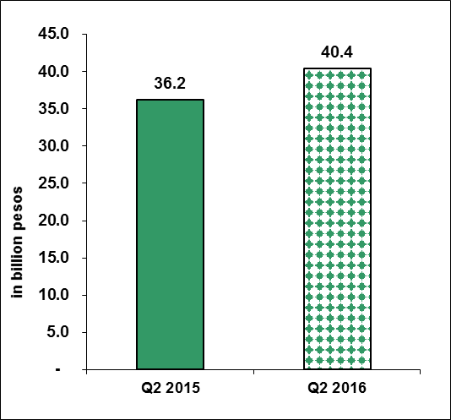

Sources of data: AFAB, BOI, BOI-ARMM, CDC, CEZA, PEZA, SBMA

BOI accounted for the largest share of foreign investments in the second quarter of 2016 with PhP 21.4 billion or 53.1 percent of the total FI. Investments from BOI grew by 96.6 percent from PhP 10.9 billion in the same period of 2015. Pledges approved by PEZA accounted for second largest share of FI, with PhP 14.1 billion or 35.0 percent. FI commitments approved by PEZA, however, declined by 41.0 percent. The rest of the IPAs accounted for 11.9 percent of the total FI. Meanwhile, foreign investments from AFAB and SMBA recorded an increase of 15 folds and 14 folds, respectively, compared to the same period last year (Table A and Part II – Table 1b).

**Table A**

**Total Approved FI by Investment Promotion Agency**

**(in million pesos)**

**Second Quarter, 2015 and 2016**



Sources of data: AFAB, BOI, BOI-ARMM, CDC, CEZA, PEZA, SBMA

**A.1.2 January to June 2016**

Total approved FI for the first six months of the year increased by 14.8 percent to   
PhP 66.6 billion from last year’s PhP 58.0 billion. Approvals from PEZA and BOI made up majority of the total FI from January to June, accounting for 45.0 percent and 44.9 percent, respectively. FI from BOI doubled in the first semester, reaching PhP 29.9 billion from   
PhP 13.3 billion last year. Meanwhile, FI approvals from PEZA declined by 22.0 percent to   
PhP 30.0 billion from PhP 38.4 billion in 2015.

**Figure 1b**

**Total Approved Foreign Investments**

**First Semester, 2015 and 2016**

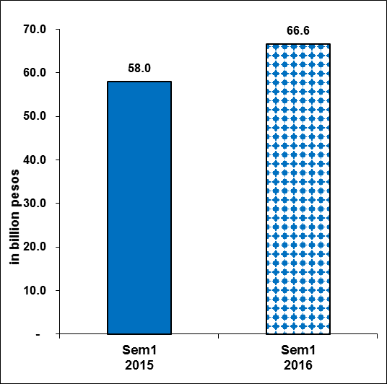

Sources of data: AFAB, BOI, BOI-ARMM, CDC, CEZA, PEZA, SBMA

Pledges from SBMA grew the fastest in the first semester, increasing by nine folds to  
PhP 4.3 billion from PhP 462.7 million in the same period last year. Likewise, FI approvals from AFAB increased by 50.1 percent to PhP 154.4 million from PhP 102.9 million. On the other hand, approved FI from CDC and CEZA declined by 77.0 percent and 76.2 percent, respectively (Table B and Part II – Table 1c).

**Table B**

**Total Approved FI by Investment Promotion Agency**

**(in million pesos)**

**First Semester, 2015 and 2016**



Sources of data: AFAB, BOI, BOI-ARMM, CDC, CEZA, PEZA, SBMA

Figure 2 below shows the series of quarterly approved FI from Q1 1996 to Q2 2016.

**Figure 2**

**Total Approved Foreign Investments (in billion pesos)**

**First Quarter 1996 to Second Quarter 2016**

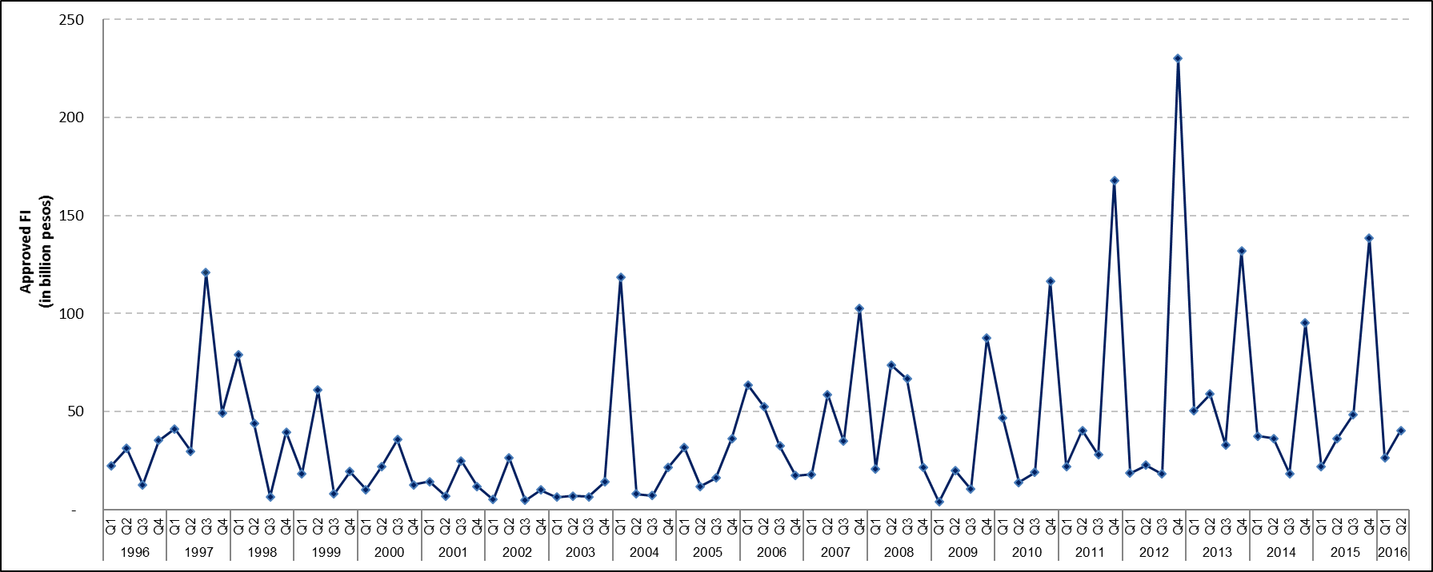

Sources of data: AFAB, BOI, BOI-ARMM, CDC, CEZA, PEZA, SBMA

**A.2 Top prospective investing countries**

**A.2.1 Second quarter 2016**

Singapore led the list of top countries as it intended to pour in PhP 10.2 billion worth of investments, accounting for 25.1 percent of the total FI during the second quarter of 2016. Investments from Singapore grew by 21.0 percent from PhP 8.4 billion in 2015. Majority of the investments are intended to finance projects in Construction. Joining Singapore as top sources of FI are Japan, with PhP 7.1 billion investment pledges or a share of 17.5 percent and South Korea, cutting in 12.7 percent or PhP 5.1 billion. Investments from Japan grew by   
75.7 percent while investments from South Korea more than tripled compared to a year ago.

Investments pledged from Japan are mostly intended to finance projects in the Manufacturing industry while FI from South Korea would fund projects in Accommodation and Food Service Activities, and Manufacturing (Figure 3a and Part II - Table 2a).

**Figure 3a**

**Total Approved FI by Country of Investor**

**Second Quarter 2016**

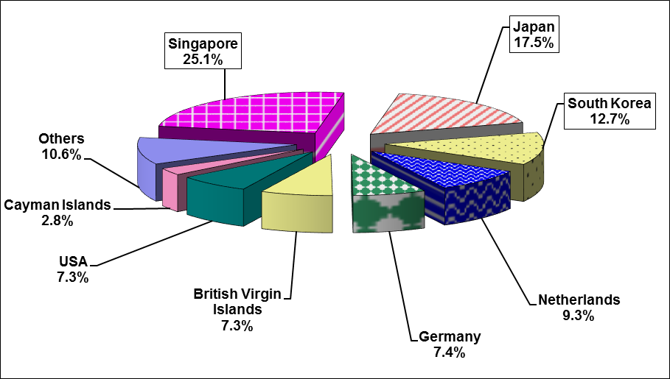

Sources of data: AFAB, BOI, BOI-ARMM, CDC, CEZA, PEZA, SBMA

**A.2.2 January to June 2016**

On a semestral basis, Singapore continued to top the list of investing countries, committing   
PhP 12.6 billion or 18.9 percent of the total FI applications, followed by the Netherlands, sharing PhP 11.8 billion or 17.7 percent, and Japan, cutting in PhP 11.4 billion or 17.2 percent share. Investments from Singapore were mainly intended to fund projects in Construction. Pledges from the Netherlands would mostly go to the Administrative and Support Service Activities and Electricity, Gas, Steam, and Air Conditioning Supply industries. Meanwhile, investments from Japan would mostly go to the Manufacturing industry. Investment pledges from Singapore registered an increase of 26.3 percent from PhP 10.0 billion in Q2 2015. Meanwhile, the FI applications from the Netherlands declined by 34.8 percent during the period while commitments from Japan increased by 2.3 percent (Figure 3b and Part II – Table 2b).

**Figure 3b**

**Total Approved FI by Country of Investor**

**First Semester 2016**

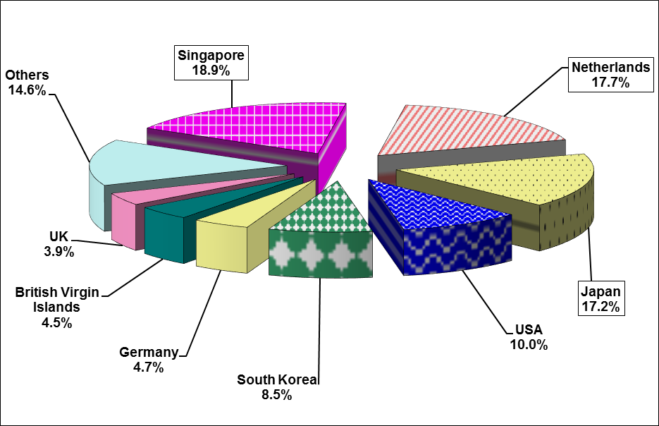

Sources of data: AFAB, BOI, BOI-ARMM, CDC, CEZA, PEZA, SBMA

**A.3 Top industries for approved foreign investments**

**A.3.1 Second quarter 2016**

Investments intended for projects in Manufacturing accounted for 35.3 percent of the total FI in the second quarter of 2016, the largest share of FI approved for the period. Investments for the industry, however, declined by 34.7 percent to PhP 14.2 from PhP 21.8 billion a year ago. Construction is set to receive the second largest amount of foreign investments at   
PhP 8.2 billion or 20.4 percent of the total. Meanwhile, Administrative and Support Service Activities would receive PhP 6.2 billion or 15.4 percent, the third largest share of the total FI (Figure 4a, Table C and Part II – Table 3a).

**Figure 4a**

**Total Approved FI by Industry**

**Second Quarter 2016**

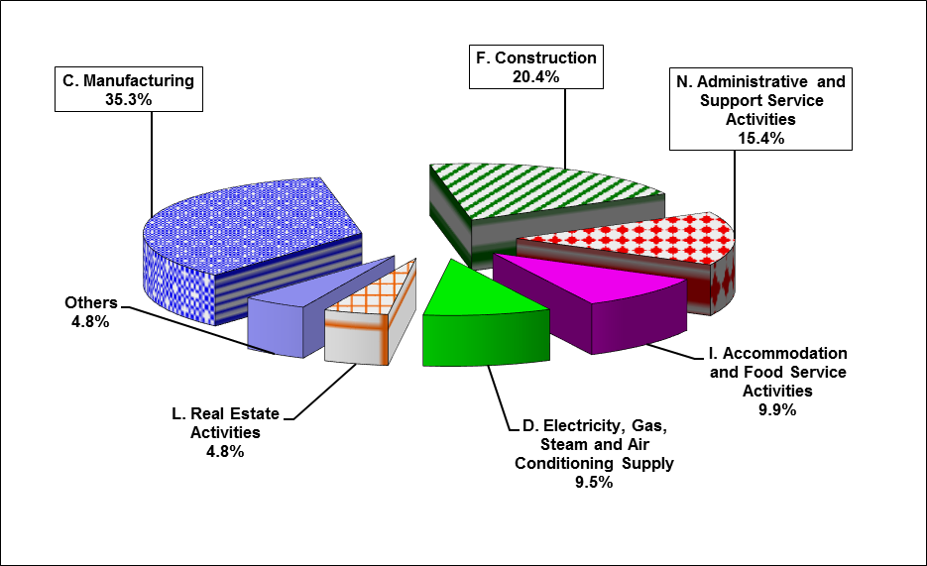

Sources of data: AFAB, BOI, BOI-ARMM, CDC, CEZA, PEZA, SBMA

**Table C**

**Total Approved FI by Industry[3] (in million pesos)**

**Second Quarter, 2015 and 2016**



Sources of data: AFAB, BOI, BOI-ARMM, CDC, CEZA, PEZA, SBMA

**A.3.2 January to June 2016**

The Manufacturing industry stands to receive the largest amount of foreign investments in the first semester, at PhP 24.1 billion or 36.1 percent share of the total approved FI. Pledges in the said industry, however, declined by 22.2 percent from PhP 30.9 billion in the first semester of 2015. Administrative and Support Service Activities came in second with investment commitments valued at PhP 11.6 billion or 17.4 percent, followed by Electricity, Gas, Steam, and Air Conditioning Supply at PhP 10.5 billion or 15.7 percent share. Proposed investments in Administrative and Support Service Activities doubled in the first semester of 2016 while FI for by Electricity, Gas, Steam, and Air Conditioning Supply grew by 14 folds (Figure 4b, Table D and Part II – Table 3b).

**Figure 4b**

**Total Approved FI by Industry**

**First Semester 2016**

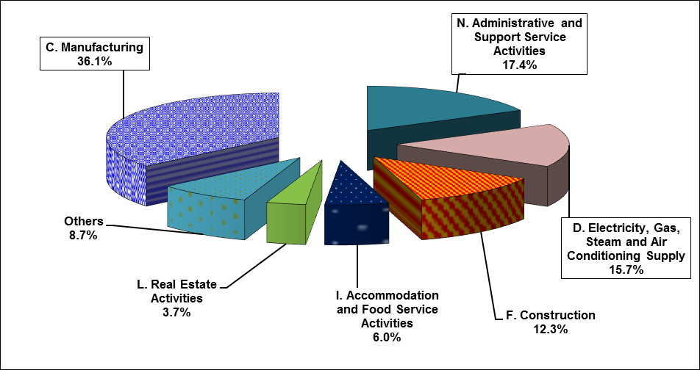

Sources of data: AFAB, BOI, BOI-ARMM, CDC, CEZA, PEZA, SBMA

**Table D**

**Total Approved FI by Industry[4] (in million pesos)**

**First Semester, 2015 and 2016**



Sources of data: AFAB, BOI, BOI-ARMM, CDC, CEZA, PEZA, SBMA

**A.4. Total approved FI by region**

**A.4.1 Second Quarter 2016**

Bulk of the approved foreign investments in the second quarter of 2016 would be intended to finance projects located in Region IVA - CALABARZON. FI pledges that would fund projects in the said region amounts to PhP 15.9 billion or 39.3 percent of the total FI. Foreign investments in Region IVA, however, declined by 28.8 percent from PhP 22.3 billion. The regions with the second and third largest amount of investments for Q2 2016 were Region VII – Central Visayas with PhP 7.2 billion or 17.8 percent and the National Capital Region (NCR) with PhP 7.1 billion or 17.7 percent of the total FI (Figure 5a, Table E and Part II – Table 4a).

Majority of the investments in Region IVA are intended for projects in Manufacturing. For Region VII, the ventures would be mostly in Construction while for NCR, most of the prospective projects would be in Administrative and Support Service Activities.

**Figure 5a**

**Total Approved FI by Region (in million pesos)**

**Second Quarter, 2015 and 2016**

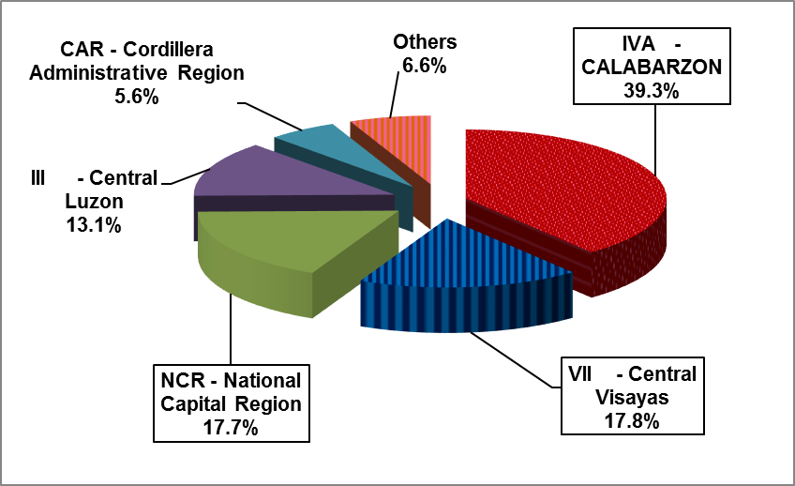

Sources of data: AFAB, BOI, BOI-ARMM, CDC, CEZA, PEZA, SBMA

**A.4.2 January to June 2016**

Region IVA – CALABARZON is set to receive the largest amount of the foreign investment commitments in the first semester of 2016, valued at PhP 23.4 billion or 35.1 percent of the total FI. Investment commitments intended for the region, however, declined by 25.5 percent in the first six months of the year. The second largest amount of FI in the first semester is intended for the National Capital Region (NCR), accounting for 19.4 percent or   
PhP 12.9 billion. Meanwhile, Region VII –Central Visayas posted the third largest share of FI at   
PhP 7.4 billion, 11.1 percent of the total approved investments. FI approvals for NCR increased by 64.0 percent while investments for Region VII grew by 64.3 percent compared to the previous year (Figure 5b, Table F and Part II – Table 4b).

Majority of the investments in Region IVA are intended for projects in Manufacturing. For NCR, the ventures would be mostly in Administrative and Support Service Activities while FI going to Region VII are mostly intended for Construction.

**Figure 5b**

**Total Approved FI by Region (in million pesos)**

**First Semester, 2015 and 2016**

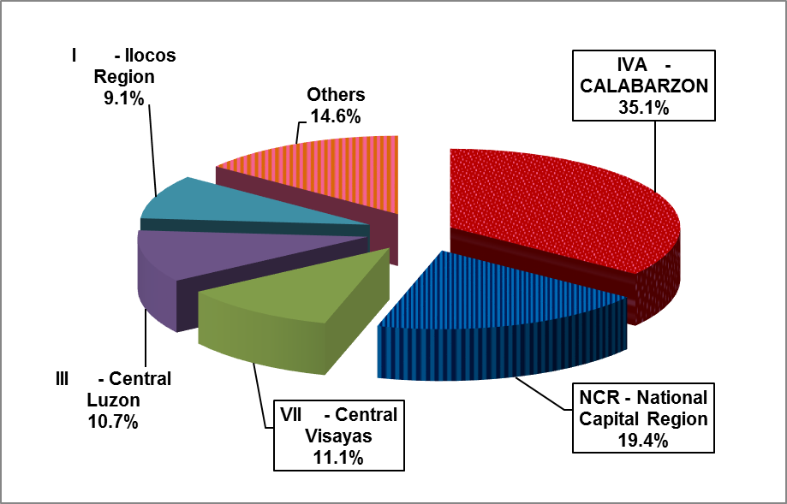

Sources of data: AFAB, BOI, BOI-ARMM, CDC, CEZA, PEZA, SBMA

**A.5 Projected employment from approved FI**

**A.5.1 Second Quarter 2016**

FI projects approved by the seven IPAs in the second quarter of 2016 are expected to generate 40,071 jobs, an increase of 54.9 percent compared to the 25,869 prospective jobs in the same period last year (Part II – Table 5a). Foreign investments coursed through PEZA are expected to generate the most number of jobs at 26,691 accounting for 66.6 percent of the total projected employment for the quarter. BOI-approved FI projects accounted for 8,361 jobs or 20.9 percent while projects approved by CDC accounted for 3,217 jobs or 8.0 percent share. The other IPAs jointly accounted for 4.5 percent of the total of job generation.

For the second quarter of 2016, only AFAB registered the largest increase in the number of expected employment, reaching 1,285 prospective jobs from 30 jobs in the same period last year. Projected employment for CDC doubled from 1,582 prospective jobs in the second quarter of 2015. Projected employment from projects approved by BOI, PEZA, and SBMA went up by 42.5 percent, 49.2 percent, and 68.5 percent, respectively.

The industries which are expected to generate the most number of jobs are Administrative and Support Service Activities at 19,267, Manufacturing at 15,760 and Construction at 1,759 jobs.

**A.4.2 January to June 2016**

Projected employment from approved FI during the first half of 2016 stood at 93,235 jobs,   
87.2 percent higher compared to 49,801 expected jobs in the same period last year. FI projects approved by PEZA are expected to generate the most number of jobs at 65,045 or 69.8 percent of the total projected employment, followed by BOI with 18,067 jobs or 19.4 percent and CDC with 5,309 jobs or 5.7 percent.

All the IPAs recorded an increase in their projected employment in the first semester of 2016, with the exception of CEZA, which registered a 48.4 percent decline in the prospective jobs. In terms of industries, Administrative and Support Service Activities is expected to generate the highest number of jobs at 35,447, followed by Manufacturing at 31,914 and Real Estate at 9,163 jobs.

**B. Approved investments of foreign and Filipino nationals**

**B.1 Total approved investments of foreign and Filipino nationals**

**B.1.1 Second quarter 2016**

Approved investments of Filipino and foreign nationals grew by 97.5 percent to   
PhP 177.7 billion from PhP 90.0 billion registered in the second quarter of 2015. Filipino nationals accounted for majority of the investments approved during the quarter, supplying   
77.3 percent or PhP 137.3 billion. The amount is more than double compared to the total investments by Filipino nationals placed a year ago (Figure 6a and Part II - Table 6a).

Around 70.1 percent of the investment commitments of foreign and Filipino nationals for the quarter were coursed through the BOI. Pledges approved by BOI grew by more than three folds to PhP 124.6 billion from PhP 37.4 billion in the same period last year. PEZA accounted for the second largest share, cutting in 20.2 percent of the total approvals for the period. However, pledges from PEZA declined by 18.4 percent to PhP 35.9 billion from PhP 44.0 billion last year. The rest of the IPAs jointly accounted for 9.7 percent of the total approved investments (Part II - Table 6a).

**Figure 6a**

**Total Approved Investments of Foreign and Filipino Nationals**

**Second Quarter, 2015 and 2016**

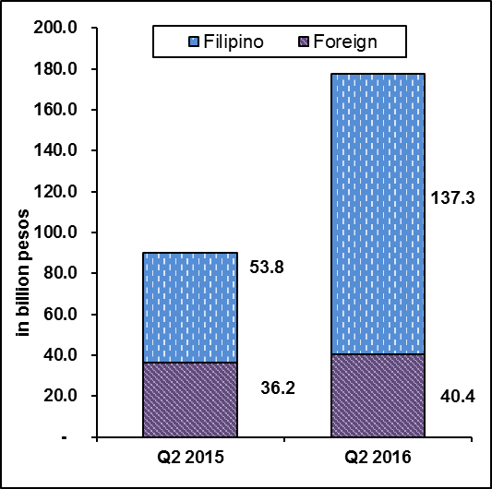

Sources of data: AFAB, BOI, BOI-ARMM, CDC, CEZA, PEZA, SBMA

**B.1.2 January to June 2016**

Investment commitments from both foreign and Filipino nationals reached PhP 227.4 billion during the first six months of 2016, an increase of 48.8 percent from PhP 186.4 billion. Of the total amount for the semester, 76.0 percent of the approved investments came from Filipino investors with PhP 210.8 billion worth of pledges (Figure 6b and Part II – Table 6b).

Investment pledges coursed through BOI from January to June 2016 accounted for 67.2 percent of the total investments in the amount of PhP 186.5 billion. Investment commitments through PEZA, with 25.2 percent share was valued at PhP 70.0 billion while investments approved by SBMA and CDC accounted for 2.5 percent or PhP 6.9 billion and 2.4 percent or PhP 6.7 billion, respectively. The other IPAs had collective pledges of PhP 7.3 billion or 2.6 percent of the total investments for the semester (Part II – Table 7b).

**Figure 6b**

**Total Approved Investments of Foreign and Filipino Nationals**

**First Semester, 2015 and 2016**

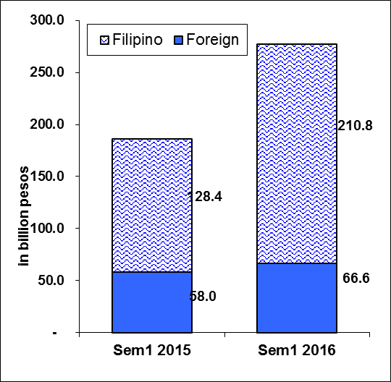

Sources of data: AFAB, BOI, BOI-ARMM, CDC, CEZA, PEZA, SBMA

**B.2 Total approved investments of foreign and Filipino nationals by industry**

**B.2.1 Second quarter 2016**

Electricity, Gas, Steam and Air Conditioning Supply topped the list of industries during the second quarter of 2016 as it stands to receive PhP 71.3 billion or 40.1 percent of the total investment pledges of foreign and Filipino nationals (Figure 7a and Part II - Tables 3a and 8a).

Investments in Construction ranked second as it accounted for 18.0 percent share or   
PhP 31.9 billion, followed by Real Estate Activities, receiving 15.8 percent or PhP 28.1 billion.

Figure 7a

Total Approved Investments of Foreign and Filipino Nationals, by Industry

**Second Quarter 2016**

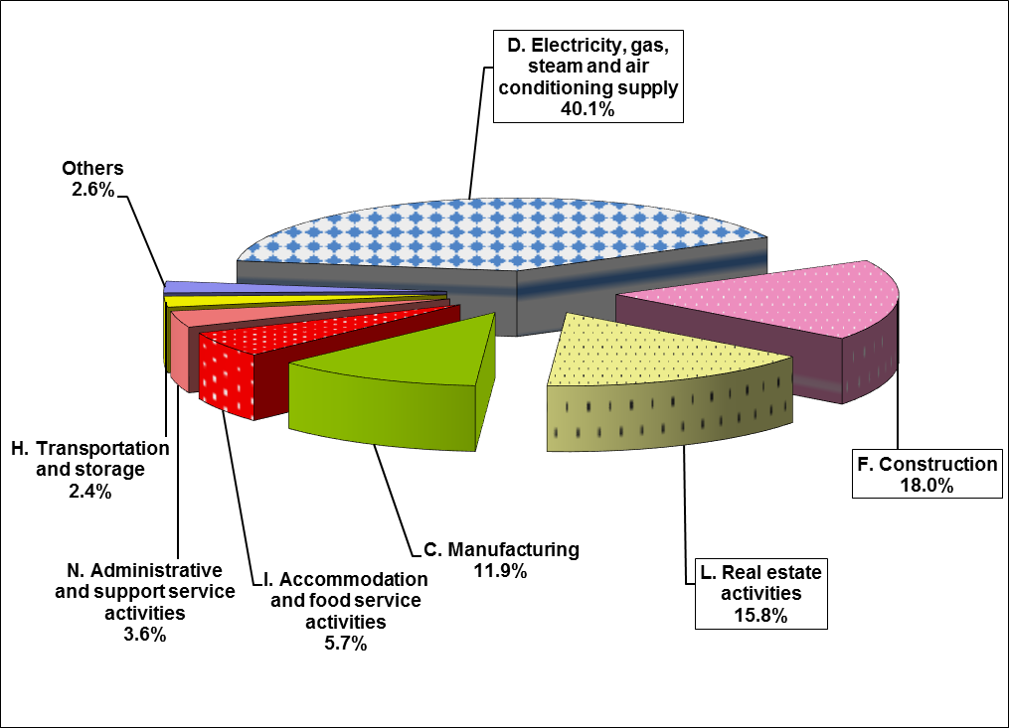

Sources of data: AFAB, BOI, BOI-ARMM, CDC, CEZA, PEZA, SBMA

**B.2.2 January to June 2016**

Topping the list of recipients of investment intentions from both foreign and Filipino nationals during the first half of 2016 are Electricity, Gas, Steam and Air Conditioning Supply in the amount of PhP 97.8 billion or 35.3 percent of total investments. Real Estate Activities came in second at PhP 63.5 billion or 22.9 percent share, followed by Manufacturing at PhP 36.3 billion or 13.1 percent. Potential investments from Electricity, Gas, Steam, and Air Conditioning Supply grew by four folds compared to last year while investments intended for Real Estate Activities increased by 29.9 percent. On the other hand, pledges intended to fund projects in the Manufacturing industry declined by 24.5 percent (Figure 7b and Part II – Table 8b).

**Figure 7b**

Total Approved Investments of Foreign and Filipino Nationals, by Industry

**First Semester 2016**

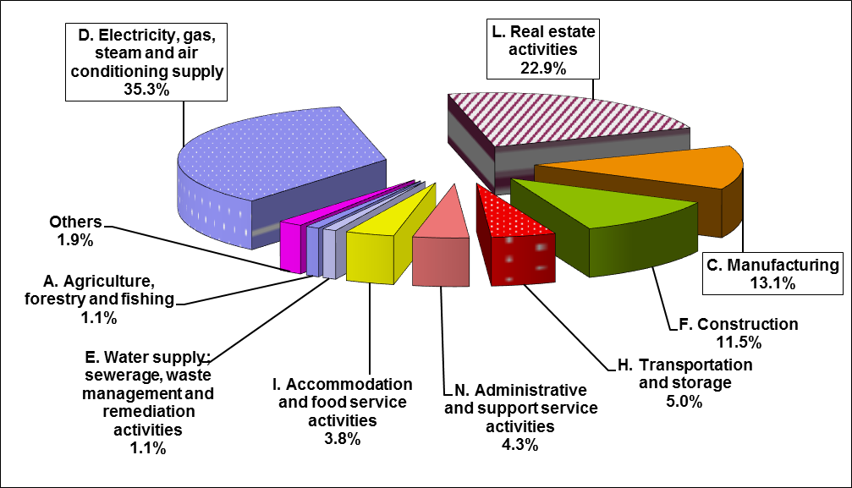

Sources of data: AFAB, BOI, BOI-ARMM, CDC, CEZA, PEZA, SBMA

**B.3. Total approved investments of foreign and Filipino Nationals by region**

**B.3.1 Second quarter 2016**

Bulk of the approved investments from foreign and Filipino nationals in the second quarter of 2016 would be intended to finance projects located in Region III – Central Luzon. Pledges for the said region amounts to PhP 43.7 billion, or 24.6 percent of the total approvals. Approved investments intended for Region III grew by seven folds compared to last year’s   
PhP 5.8 billion. The regions with the second and third largest amount of investments for Q2 2016 were the National Capital Region (NCR) with PhP 36.3 billion or   
20.5 percent and Region IVA – CALABARZON followed with PhP 35.6 billion or 20.0 percent (Figure 8a and Part II – Table 9a).

Majority of the investments in Region III are intended for projects in Electricity, Gas, Steam and Air Conditioning Supply. For NCR, the ventures would be mostly in Real Estate while for Region IVA, most of the prospective projects would be in Electricity, Gas, Steam and Air Conditioning Supply and Manufacturing.

**Figure 8a**

**Total Approved Investments of Foreign and Filipino Nationals by Region (in million pesos)**

**Second Quarter, 2015 and 2016**

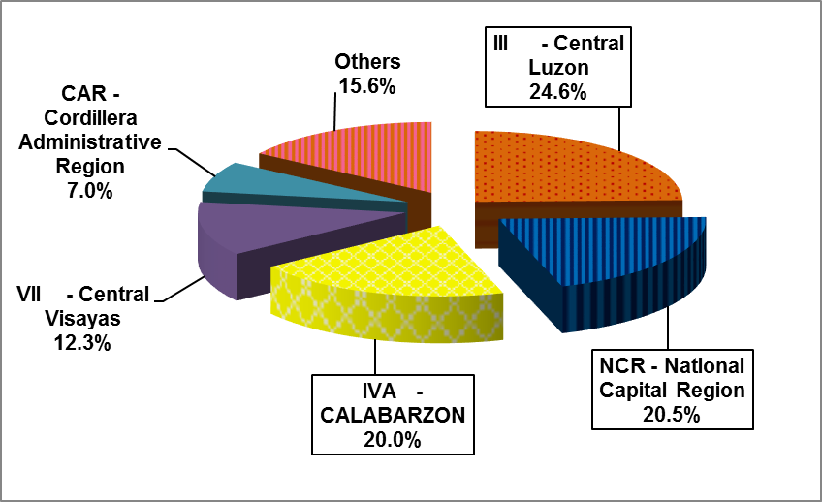

Sources of data: AFAB, BOI, BOI-ARMM, CDC, CEZA, PEZA, SBMA

**B.3.2 January to June 2016**

The National Capital Region stands to receive the largest amount of investments from foreign and Filipino nationals in the first half of 2016, amounting to PhP 68.3 billion or 24.6 percent. Investment commitments intended for the region increased by 82.9 percent during the period. Region III – Central Luzon received the second largest amount of total investment pledges in the first semester, accounting for 20.8 percent or PhP 57.6 billion while Region IVA – CALABARZON received the third largest share of commitments at 19.1 percent of the total investment pledges. FI approvals for Region III doubled in the first semester of 2016 while approved investments from Region IVA declined by 15.5 percent (Figure 8b and Part II – Table 9b).

Majority of the investments in NCR are intended for projects in Real Estate. For Region III, ventures would mostly be in Electricity, Gas, Steam and Air Conditioning Supply while investments for Region IVA would mostly be in Manufacturing.

**Figure 8b**

**Total Approved Investments of Foreign and Filipino Nationals by Region (in million pesos)**

**First Semester, 2015 and 2016**

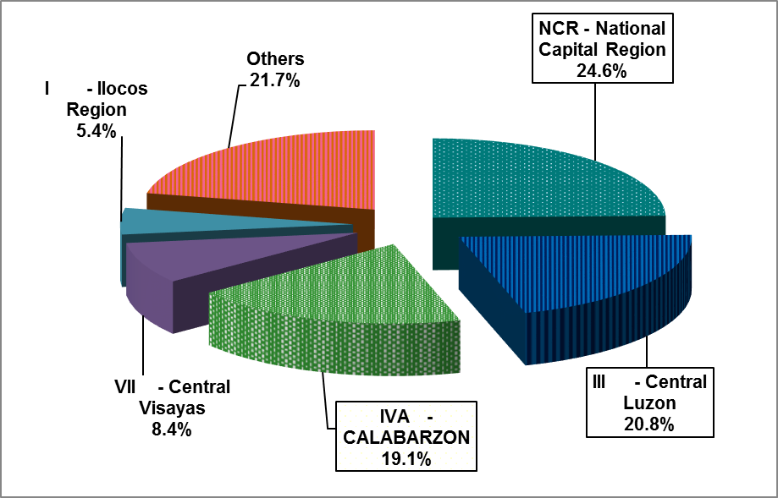

Sources of data: AFAB, BOI, BOI-ARMM, CDC, CEZA, PEZA, SBMA

**B.3 Projected employment from approved investments of foreign and Filipino nationals**

**B.3.1 Second quarter 2016**

Total projects of foreign and Filipino investors approved by the seven IPAs for the second quarter of 2016 are expected to generate 53,998 jobs, an increase of 49.2 percent from the projected employment of 36,196 in the same period last year. Out of these anticipated jobs, 74.2 percent would come from projects with foreign interest.

**Figure 9a**

**Projected Employment**

**Second Quarter, 2015 and 2016**

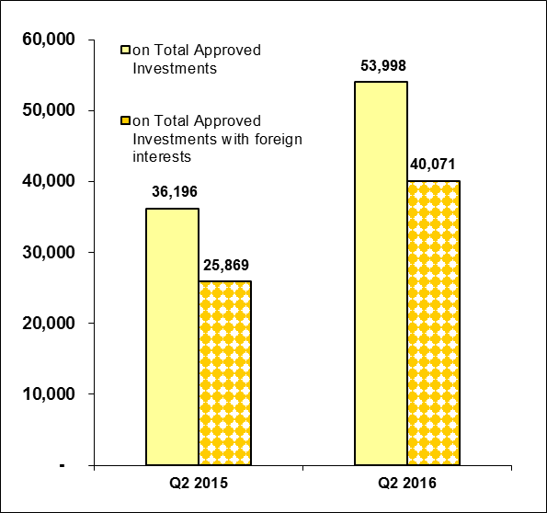

Sources of data: AFAB, BOI, BOI-ARMM, CDC, CEZA, PEZA, SBMA

Projects registered through PEZA posted the largest number of projected employment at 27,648, contributing 51.2 percent of the total expected jobs for the period. BOI-approved projects recorded 17,366 potential jobs, with a share of 32.2 percent while pledges coursed through CDC are expected to generate 4,671 jobs or 8.7 percent. Meanwhile, the combined investments from AFAB, CEZA, and SBMA are expected to generate 4,313 jobs (Figure 9a and Part II – Table 10a).

**B.3.2 January to June 2016**

For the first six months of 2016, a total of 113,327 jobs are expected to be generated from approved investments of foreign and Filipino nationals, 39.2 percent higher compared to 81,393 jobs last year. Around 58.5 percent or 66,284 jobs would come from investment pledges coursed through PEZA followed by BOI with 30,207 jobs which represents 26.7 percent of the total projected employment. Other IPAs would have a combined share of 14.9 percent of the total jobs expected (Figure 9b and Part II – Table 10b).

.

**Figure 9b**

**Projected Employment**

**First Semester, 2015 and 2016**

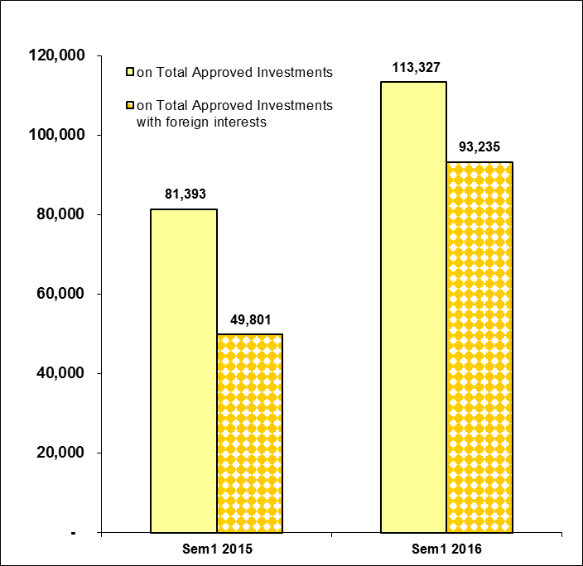

Sources of data: AFAB, BOI, BOI-ARMM, CDC, CEZA, PEZA, SBMA

**B.4 Projected employment from approved investments of foreign and Filipino nationals by industry**

**B.4.1 Second quarter 2016**

In terms of projected employment by industry, Manufacturing is expected to have the most number of jobs to be generated at 20,435 in the second quarter of 2016. Projected employment for the said industry is double compared to last year’s employment. Second is the Administrative and Support Service Activities which is expected to generate 20,074 jobs, higher by 70.8 percent compared to second quarter of 2015. Next is Real Estate Activities which is expected to generate 3,788 jobs. Projected employment for Real Estate, however, declined by 51.4 percent compared to last year’s employment (Table E).

**Table E**

**Projected Employment from Approved Investments by Industry**

**Second Quarter, 2015 and 2016**



Sources of data: AFAB, BOI, BOI-ARMM, CDC, CEZA, PEZA, SBMA

**B.4.2 January to June 2016**

Of the 113,327 projected jobs in the first semester of 2016 from prospective ventures of foreign and Filipino investors, Manufacturing (37,520 jobs), Administrative and Support Service Activities (36,433 jobs), and Real Estate Activities (13,872 jobs) are foreseen to supply the bulk of projected employment with shares of 33.1 percent, 32.1 percent, and 12.2 percent, respectively (Table F).

**Table F**

**Projected Employment from Approved Investments by Industry**

**First Semester, 2015 and 2016**



Sources of data: AFAB, BOI, BOI-ARMM, CDC, CEZA, PEZA, SBMA

**C. Approved investments in the Information and Communications Technology (ICT) Industry**

**C.1 Total approved FI in ICT**

##### C.1.1 Second quarter 2016

Approved foreign investments in the ICT in the second quarter of 2016 amounted to   
PhP 6.0 billion, higher by 93.9 percent compared to the previous year. ICT represents 15.0 percent of the foreign investment pledges during the period. PEZA consistently receives the bulk of investment pledges in ICT, with a share of 98.1 percent during the period. Investments in ICT from PEZA more than doubled to PhP 5.9 billion from PhP 2.5 billion in the previous year. (Part II – Table 11a).

# C.1.2 January to June 2016

Potential foreign investments in ICT in the first six months of 2016 grew by 95.6 percent, amounting to PhP 12.1 billion from previous year’s PhP 6.2 billion. FI in ICT coursed through PEZA amounted to PhP 12.0 billion, double compared to PhP 5.3 billion a year ago. All the other IPAs recorded a decline in the FI approvals for ICT projects in the first half of 2016. (Part II – Table 11b).

FI in ICT would account for 18.2 percent of the total FI registered in January to June 2016 (Part II – Tables 10b and 11b).

**C.2 Total approved investments in ICT of foreign and Filipino nationals**

##### C.2.1 Second quarter 2016

Pledges in ICT investments made by foreign and Filipino nationals in the second quarter of 2016 amounted to PhP 6.3 billion, up by 35.2 percent from PhP 4.6 billion in Q2 2015. Foreign nationals remained as the major source of investment pledges in ICT, committing 96.4 percent or PhP 6.0 billion worth of investments. Filipino investors, on the other hand, committed   
PhP 228.7 million or 3.6 percent of the total ICT investments (Table G and Part II – Table 11a).

**Table G**

**Total Approved Investments in ICT by Foreign and Filipino Nationals**

**Second Quarter 2015 and 2016**

**(in million pesos)**



Sources of data: AFAB, BOI, BOI-ARMM, CDC, CEZA, PEZA, SBMA

* 1. **C.2.2 January to June 2016**

Overall ICT investments made by foreign and Filipino nationals during the first six months of the year declined by 6.4 percent to PhP 12.6 billion from last year’s pledges of PhP 13.5 billion (Part II - Table 11b). Foreign investments in ICT increased by 95.6 percent while ICT investments from Filipino nationals declined by 93.5 percent. Potential investments in ICT by Filipino nationals amounted to PhP 475.7 million, accounting for 3.8 percent of the total approved projects in ICT (Part II - Tables 11b and 5b).

**C.3 Total approved investments in ICT of foreign and Filipino nationals by ICT sub-industry**

##### C.3.1 Second quarter 2016

IT services remained as the main recipient of investment intentions in ICT of foreign and Filipino nationals during the quarter as it stands to receive PhP 6.1 billion or 97.3 percent of total ICT projects. Information and communication accounted for 2.7 percent or PhP 166.8 million. Investments in IT Services more than doubled in the second quarter of 2016 while investments in information and communication declined by 88.8 percent (Part II – Table 13a).

# C.3.2 January to June 2016

Of the PhP 12.6 billion committed by foreign and Filipino investors to fund projects in ICT during the first semester of 2016, 93.4 percent or PhP 11.8 billion would go to IT Services. Information and Communication came in second at PhP 824.7 million, contributing a share of 6.5 percent. (Part II – Table 13b).

**C.4 Projected employment from approved investments in ICT of foreign and Filipino nationals by ICT sub-industry**

**C.4.1 Second quarter 2016**

Approved investments of foreign and Filipino nationals in ICT are anticipated to create 20,572 jobs in the second quarter of 2016, 45.5 percent higher compared to the 14,135 jobs expected in Q2 2015. IT Services is expected to supply 19,595 jobs or 95.3 percent of total employment in ICT while 997 jobs are seen to be generated from information and communication (Table L and Part II – Table 14a).

Projected employment from ICT sub-industry accounted for 38.1 percent of total jobs expected from the investment projects of foreign and Filipino nationals approved in the second quarter of 2016 (Part II – Tables 14a and 10a).

**Table H**

**Projected Employment from Approved Investments in ICT by ICT Sub-industry**

**Second Quarter 2015 and 2016**



Sources of data: AFAB, BOI, BOI-ARMM, CDC, CEZA, PEZA, SBMA

# C.4.2 January to June 2016

Projected employment from ICT projects in the first six months of the year totaled 43,990 jobs, 53.4 percent higher than 28,671 jobs expected in the same period last year. IT services is expected to absorb 36,380 jobs or 82.7 percent of the total prospective employment while   
7,610 jobs or 17.3 percent would be from information and communication (Figure 10a and Part II – Table 14b).

1. **Actual foreign direct investments (FDI) in the Balance of Payments[5]**

**D.1 Total BOP FDI in US dollars and Philippine pesos[6]**

**D.1.1 April to May 2016**

Foreign direct investments (FDI) in the Balance of Payments (BOP) as compiled by the Bangko Sentral ng Pilipinas (BSP) recorded a net inflow of US$ 2.6 billion in the period April to May of 2016, an increase of three folds compared to US$ 785.0 million in the same period a year ago. Equity other than reinvestment of earnings was valued at US$ 904.0 million. On the other hand, reinvestment of earnings and net debt instruments amounted to US$ 139.0 million and   
US$ 1.5 billion, respectively, during the period (Figure 10a and Part II – Table 15a).

**Figure 10a**

**Balance of Payments FDI (in million US$)**

**April to May, 2012 and 2016**



Source of data: BSP

In peso terms, FDI net inflows for the second quarter of 2016 amounted to PhP 119.0 billion, three times higher compared to PhP 34.9 billion in the same period last year (Part II – Table 16a).

**D.1.2 January to May 2016**

As reported by the BSP, net FDI inflows from January to May of the year amounted to  
US$ 3.9 billion, more than double compared to US$ 1.6 billion recorded in the same period in 2015. Equity other than reinvestment of earnings during the period reached US$ 1.4 billion, higher by three folds compared to the previous year (Figure 10b and Part II – Table 15b).

Net inflows of reinvestment of earnings reached US$ 320.0 million, inching up by 0.3 percent compared to the previous year. Meanwhile, net debt instruments registered an inflow of   
US$ 2.1 billion during the period.

**Figure 10b**

**Balance of Payments FDI (in million US$)**

**January to May, 2015 and 2016**



Source of data: BSP

In peso terms, FDI in the BOP for January to May 2016 recorded a net inflow of   
PhP 180.1 billion, more than double compared to the net inflow of PhP 72.8 billion in the same period last year (Part II – Table 16b).

1. Approved FI represents the amount of proposed contribution or share of foreigners to various projects in the country as approved and registered by the IPAs. This consists of equity, loans and reinvested earnings. (See Annex A – Technical Notes)
2. FDI refers to actual foreign direct investments in the BOP, with the foreign investors owning 10 percent or more of the ordinary shares or voting power or the equivalent. Data refers to net FDI flows consisting of non-residents’ equity capital placements less non-residents’ equity capital withdrawals plus reinvested earnings plus net intercompany loans.
3. Industry classification is based on the 2009 Philippine Standard Industrial Classification (PSIC).
4. Industry classification is based on the 2009 Philippine Standard Industrial Classification (PSIC).
5. BSP media release dated September 10, 2016
6. Using monthly average buying and selling rates downloaded from BSP website